Company Information of Shenzhen Environmental Electroplating Company (SEEC)
Company Name | Shenzhen Environmental Electroplating Company (SEEC)
Business Nature | Electroplating  Nickel and Zinc plating (barrel plating)
Products | Electroplating for screws and metal parts
Major Markets / Clients | China / America / Japan / Europe
Manufacturing Processes | Loading workpieces into plating barrel → degreasing → rinsing → acid dipping → rinsing → nickel plating / zinc plating → rinsing → passivation / coating → rinsing → drying → packing → delivery
Address  Office and Plant Locations | Hong Kong office : 6/F, No. 1, On Yiu Street, Siu Lek Yuen, Shatin Tin, N.T.  Shenzhen factory : No. 20, Shenzhen Electroplating Industrial Estate, Longhua Town, 518109 Shenzhen China.
Factory Areas | 2,300 square metres (including green area, staff canteen and warehouse)
No. of employees | Hong Kong Office : 5 staff  Shenzhen Factory : 60 staff
Main facilities / equipment  (Shenzhen factory) | Barrel plating lines and associated equipment  Centrifugal dryers  Deionized (DI) water generator  Laboratory  Air scrubber  Ventilation system  Cooling tower  Emergency electricity generator  Water pump  Staff canteen
Surrounding Environment | Situated in the Shenzhen Electroplating Industrial Estate which is particularly constructed for electroplating companies, thus the factory is surrounded by other plating factories. The Industrial Estate’s central wastewater treatment plant is located next to the factory where all wastewater is collected from the factories in the industrial estate. All domestic and industrial wastewater generated from our factory is discharged to the Shenzhen Industrial Estate’s treatment plant for central treatment. The Industrial Estate’s waste collector collects all wastes generated on factories.
Potential environmental impacts from the operations | - Wastewater discharge from degreasing, electroplating and rinsing processes. Wastewater is discharged to the central wastewater treatment plant.  - Solid wastes include general refuse, paper waste from office, packaging bags and rejected products (metal).  - Chemical wastes from spent plating baths, sludge and chemical containers.  - Acid / alkaline / metal mists from electroplating baths  - Significant use of electricity, water and chemicals for production processes
Special client’s environmental requirements | For Europe and America customers:  - Lead free plating  - Cadmium free plating  For Japan customers:  - Use Chromium (III) to replace Chromium (VI)
Relevant Legislation Related to Client’s Environmental Requirements | For Europe  - Waste Electrical and Electronic Equipment (WEEE) Directive (Directive 2002/96/EC)  - Restriction of Hazardous Substances in electrical and electronic equipment (RoHS) Directive (Directive 2002/95/EC)  - Nickel Free Directive (Directive 94/27/EC)  - Packaging and Packaging Waste Directive (Directive 94/62/EC)  For Japan  - Revised Recycling Law (Formally known as the Law for Promotion of Effective Utilization of Resources)  - Containers and Packaging Recycling Law (Formally known as Law for Promotion of Sorted Collection and Recycling of Containers and Packaging)

Disclaimer : The information provided in this practical example is purely hypothetical and intended to illustrate the development and implementation of ISO 14001 EMS. Users will need to ensure that the information they insert is appropriate for their own situation.

Factory Layout Plan

Nickel Plating Line
Zinc Plating Line
Barrel Degreasing
Barrel Degreasing

Acid & Alkali streams to Central Wastewater Treatment Plant

Passivation
Exit

Office

Centrifuge Drying

Deionized Water Generator

QC
Room

Warehouse

Packing Area

Laboratory

Staff Canteen

Process flow

Workpieces loading

Degreasing

Rinsing

Acid Dipping
Rinsing

Nickel Plating
Acid Zinc Plating

Rinsing
Rinsing

Cyanide Dipping
Passivation

Rinsing

Drying

Products
Location of Shenzhen Environmental Electroplating Company (SEEC)

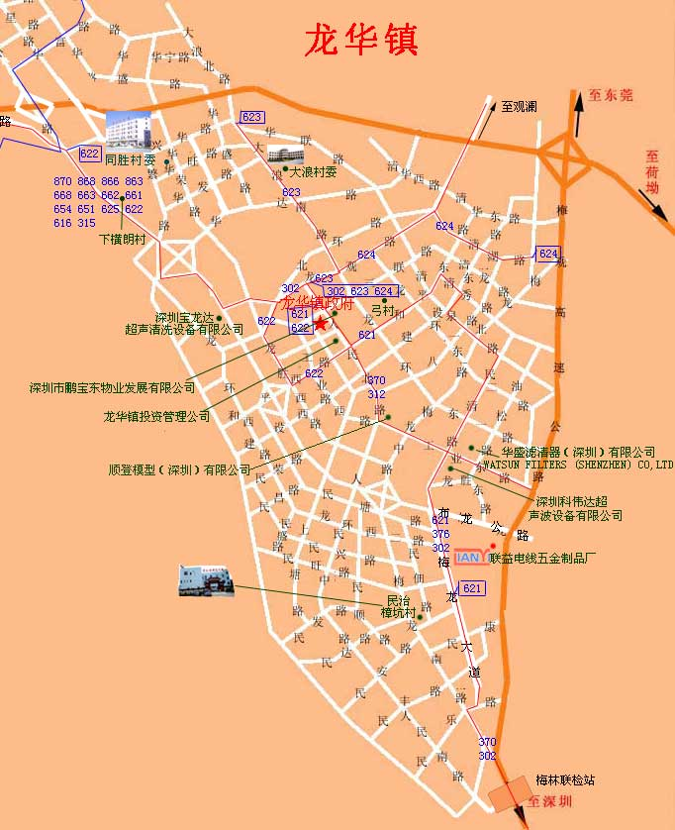

Location of SEEC in Shenzhen Longhua Town:
No. 20, Shenzhen Electroplating Industrial Estate, Longhua Town

